Lab#7 Modern Javascript(ES5\ES6\ESNEXT) and Babel SSUET/QR/114

**LAB # 7**

**Modern Javascript (ES5\ES6\ESNEXT) and Babel**

**OBJECTIVE**

To get familiar with modern Javascript and Babel, and their features.

# Lab Task

1. ***Modern JS*** 
   1. Create a class called *Library* and add few properties like *sections*, *books*, *manager*, and *openingTime* and *closingTime*.
   2. Add few functions like *manageLibrary, issueBooks, addNewSection, openLibrary,* and *closeLibrary*.
   3. Use arrow functions instead of regular functions for all function definition.
   4. Return promise from *issueBooks*, *openLibrary* and *closeLibrary* functions.
   5. Return books from issueBooks promise. Use *then* to receive the result.
   6. Return openingTime from openLibrary function. Use *setTimeout* and resolve after 2 seconds. Use *async/await* keywords pair to get the results.
   7. Return closingTime from closeLibrary function. Use *setTimeout* and resolve after 1 second. Use *async*/*await* keywords pair to get the results.
   8. Create instances of the *Library* class and call each function as mentioned above.
   9. Loop through the keys of each instance using for-in loop and log the keys. **Output:**

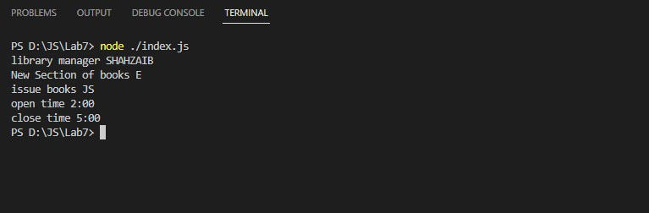

1. *Babel* 
   1. Create *Student* registration form using React.
   2. Create *Teacher* login form using React.
   3. Create two routes for each student and teacher forms and provide links to redirect to their respective forms.
   4. Render React forms using Babel transpiler.

SWE-315L Web Engineering

Lab#7 Modern Javascript(ES5\ES6\ESNEXT) and Babel SSUET/QR/114

**OUTPUT:**



# Home Task

1 *Modern JS*

a. Create a *generator* function called *generateRegistrationNumbers.*

1. Accept the parameter asking the upper *limit* of the Registration number to be generated.
2. Calling the *next* method should return first registration number starting from 1 iii. Calling the *next* method of generator again should return the next number. iv. If the limit has been reached, the generator should stop giving next number no matter how many more times you call the *next* method of generator.

OUTPUT:

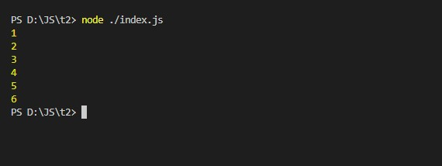

Git Link: www.github/wahaj461

SWE-315L Web Engineering